 |  | 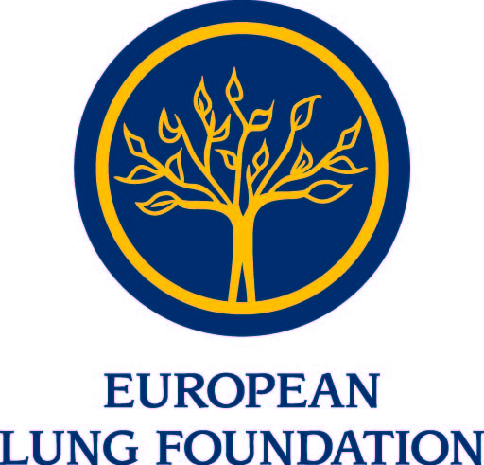
 | 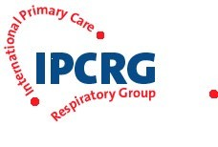  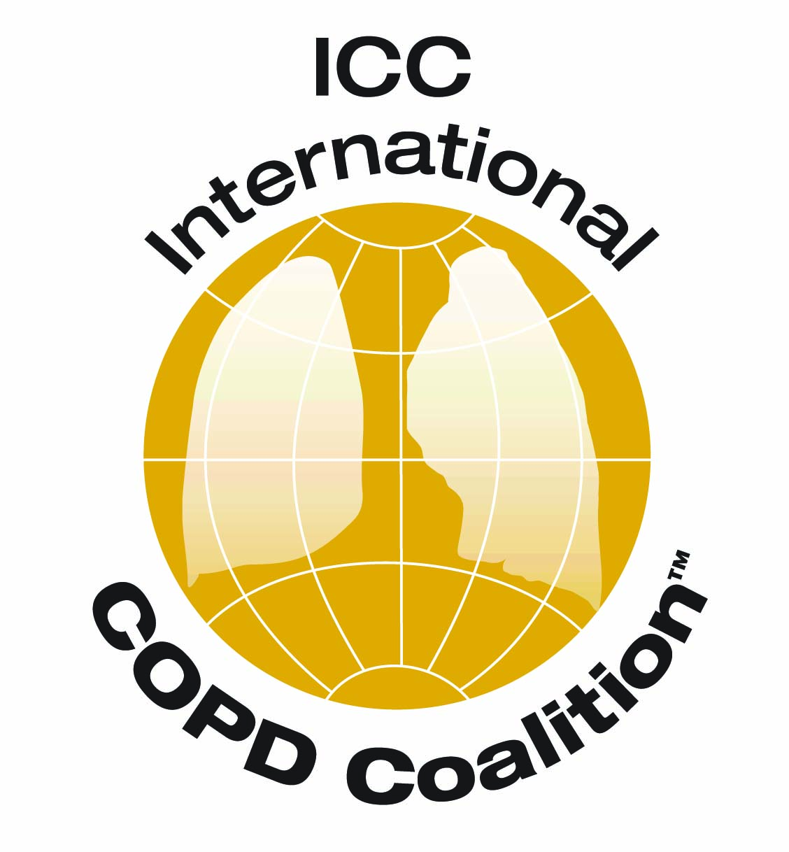 | 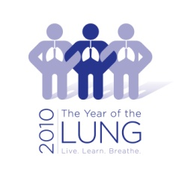
European and International Health Organisations unite to call for European action to combat Chronic Obstructive Pulmonary Disease (COPD)
COPD affects 44 million people in Europe and is the 4th leading cause of death worldwide. The WHO predicts it will become the 3rd by 2030. The European Federation of Allergy and Airways Diseases Patients’ Associations (EFA) launched a Call to Action on 30th of June at the European Parliament.
It calls on the EU institutions and Member States to develop a strategic, comprehensive and integrated European approach to respiratory diseases with a focus on COPD, rather than disperse initiatives which is currently the case. COPD causes restriction of airflow and difficulty to breathe, and can become very disabling in its ‘very severe’ stage.
“For those affected by chronic respiratory problems, this simple act of breathing can become a challenge, a source of suffering and anguish. I couldn’t be more sympathetic to the objectives of your Call to Action.” wrote Jerzy Buzek, the President of the European Parliament in his foreword for the event.
“I support the Call to Action and I will continue combating for patients with COPD” said Catherine Stihler, MEP who hosted the event, after signing the Call.
Allan Stone, a patient with COPD described his own experience with this disease. “I was first told by my doctor that it was just a cold, but it turned out to be moderate COPD” he said. Access to early diagnosis is difficult across Europe according to patients’ associations surveyed by EFA. Early diagnosis can be confirmed with a simple spirometry test, and it enables timely treatment and lifestyle changes to stop progression of the disease. But COPD is not known by the general public, and often mistaken for a minor “smoker’s cough”.
“COPD has been neglected, had there been earlier political intervention, prevalence and mortality wouldn’t be so high. All stakeholders, the EU institutions and Member States must act now to curb COPD and improve the care for this disease.” declared Marianella Salapatas, EFA President.
EFA and the signatories of the 7 point Call-to-action urge the EU to make COPD a political priority, to raise awareness of this disease among the public and healthcare professionals, to encourage its early diagnosis, to improve the care and prevention of COPD, improve air quality, and to support research.
“EFA has been one of the first members of the GARD and I very much welcome and support this Call to Action” said Professor Jean Bousquet, Chairman of the Global Alliance Against Respiratory Disease.
The following organizations signed the Call and said:

European Respiratory Society (ERS):
“Although partly preventable, there is no cure for COPD. More research is urgently needed for surveillance, better management and to develop a cure for COPD. We need to improve patient care and their quality of life.” Professor Nikolaos Siafakas, President of the European Respiratory Society.
European Lung Foundation (ELF):
"COPD and the risk factors associated with it are still gravely under-recognised among the general public. We urgently need novel strategies to ensure the public know about and care for their lungs, and understand that COPD can be tested for and detected early to enable the best outcome." Professor Kai-Hakon Carlsen, Chair of the European Lung Foundation.

Health and Environment Alliance (HEAL):
“Poor indoor and outdoor air quality (such as damp, mould and dust in buildings or pollution) is particularly harmful for people with COPD. The call to action underlines that the EU needs to step up its efforts to ensure healthy air both outdoors and indoors. This includes putting forward suggestions for an integrated, harmonised European approach to tackle indoor air quality.” Anne Stauffer, Policy Manager of the Health and Environment Alliance.
International COPD Coalition (ICC): “ICC supports the Call to Action, which is a crucial part of the global effort to make COPD a political priority and to provide COPD patients with the rights they deserve.” Larry Grouse, MD, PhD, Executive Director, International COPD Coalition (ICC).

International Primary Care Respiratory Group (IPCRG): "The IPCRG encourages primary care clinicians to make an early COPD diagnosis by using spirometry effectively. This supports smoking cessation and enables earlier interventions that can improve quality of life and decrease mortality.” Miguel Roman, President of the IPCR

The European Network for Smoking and Tobacco Prevention (ENSP) have also signed the Call to Action.

EFA Contact information
Laurene Souchet
EFA EU policy and project assistant
Phone: +32 (0)2 227 2712
info@efanet.org

