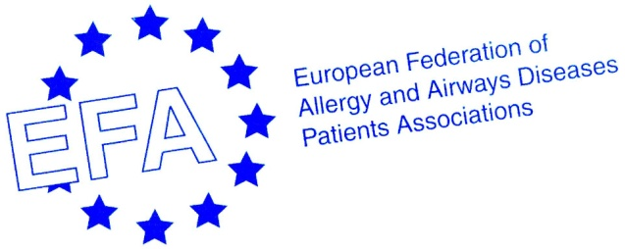
European Federation of Allergy and Airways Diseases Patients’ Associations (EFA) Training
“Meet and Greet the European Union (EU) Institutions”
Date: 20th-21st of March for one and a half day

Rationale: Thanks to this event, EFA members will have the opportunity to come to Brussels for one and a half day and to have a general overview of how the EU works and of its policies that are related indirectly or directly to people with allergy, asthma and COPD in Europe. They will also have the opportunity to dig deeper in a case study, a legislative text under review. They will meet and greet key people at the Commission working on issues important to them and MEPs from their country. As a result, they will better understand how the EU policies channel the decisions of the national governments and how with EFA, patients’ associations can contribute to the EU decision-making process.

Agenda

Day 0 – 19th of March (Monday)
Tentative venue: Hotel du Congres (42, Rue du Congres – B-1000, Brussels)
Late afternoon | Arrival of the members  Optional visit of the Parlamentarium, European Parliament new interactive learning centre
Evening | Dinner
Day 1 – 20th of March (Tuesday)
Venue: EFA office (35, Rue du Congres – B-1000, Brussels)
09:30 | Welcome by Susanna Palkonen, EFA Executive Officer
09:50 | First presentation: The EU and its functioning – David Brennan, EFA EU Policy and Project Assistant  → The supremacy over national legislations and the “institutional triangle”: Parliament, Council, Commission  Questions and answers
10:10 | Second presentation: Health policy in the EU – Roberta Savli, EFA EU Policy and Project Officer  → The novelties introduced by the Treaty of Lisbon and how they relate to health: the legal basis, shared competence EU/Member States in case of common safety concerns and a new integration principle – The EU should take into consideration a high level of human health protection in the definition and implementation of all its policies and activities (arts. 9 TUE, 168 TFUE)  → Past actions and possible future developments  Questions and answers
10:30 | Coffee break
10:50 | Third presentation: How to engage with the decision-making process – Tamsin Rose, Director at Progress Works, former Secretary-General of the European Public Health Alliance  → European Parliament (EP): the legislative process and other initiatives  → European Commission (EC): the new “comitology” and the implementation of acts – The Commission has the power to implement legally binding acts when uniform conditions for their implementation are needed (art. 291 TFEU)  Questions and answers
12:00 | Lunch
Venue: European Parliament (Room)
14:00 | Meeting the secretariat of the Committee on Environment, Public Health and Food Safety (ENVI) – TBC  → The latest EU developments in the field of health, with a special focus on their link with the environment  E.g.: Food labeling regulation implementation, air pollution  Questions and answers
15:00 | Meeting the secretariat of the Committee on Industry, Research and Energy (ITRE) – Gai Oren, Administrator responsible for Research  → The latest EU developments in the field of research, with a focus on the forthcoming Eighth Framework Programme for research and technological development (FP8)  Questions and answers
16:00 | Networking coffee break
16:30 | Meetings with MEPs from the countries of the members present  Questions and answers
19:00 | Dinner
Day 2 – 21st of March (Wednesday)
Venue: EFA office (35, Rue du Congres – B-1000, Brussels)
09:30 | Case-study: Tobacco products directive (to be reviewed in 2012)  → 09:30 General overview given by DG SANCO officials on this dossier (Unit D4 Substances of human origin and Tobacco control) – Anna-Eva Ampelas, Legal Officer  → 10:00 Workshop moderated by Smoke-free partnership – TBC
10:45 | Networking coffee break
11:00 | Meeting DG SANCO officials, Unit C4 Health determinants – Natacha Grenier, Policy Officer  → The activities of DG SANCO related to chronic respiratory diseases  Questions and answers
12:00 | Lunch

